2024 SIDS Awareness 5K
(in memory of Landen)
Sponsorship Form

Run/walk will be held Saturday, October 12, 2024
The start & finish will be at Mill Park Shelter House at 120 E. High Street, St. Marys, Ohio 45885
Registration will open at 8 a.m. * 5KRun/Walk to begin at 9 a.m.

SPONSORSHIP OPPORTUNITIES

- Presenting Sponsor $2,500
- Prominent Signage at the event
- 6 free entries to the event (submit your free entry information on the back of this form)
- Signage at the roundabout
- Name announced at the event
- Opportunity to give promotional materials in entry packets
- Recognition on the SIDS Awareness 5K Facebook Event

- Corporate Sponsor $1,000
- Mile Marker Sponsorship
- 4 free entries to the event (submit your free entry information on the back of this form)
- Name announced at the event
- Recognition on the SIDS Awareness 5K Facebook Event

- Supporting Sponsor $500
- 2 free entries to the event (submit your free entry information on the back of this form)
- Recognition on the SIDS Awareness 5K Facebook Event
- Name announced at the event
- Sign on course

- Friend Sponsor $100
- 1 free entry to the event (submit your free entry information on the back of this form)
- Name announced at the event

TIMED AWARDS- Timed awards will be provided for the overall best time for male and female and top performers in male and female categories. Everyone in attendance will be eligible for raffle prizes at the SIDS Awareness 5K.
2024 SIDS Awareness 5K Sponsorship
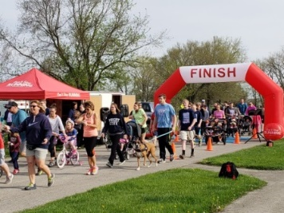
Please return this Sponsorship form by Friday, September 27, 2024 to:
JTD Hospital Foundation, 200 St. Clair, St. Marys, Ohio 45885

Sponsorship Level: Presenting___ Corporate___ Supporting ___ Friend ___

Company/Organization: ___________________________________________________

Contact: ____________________________________Phone:_______________________

Address: ________________________________________________________________

E-Mail: _________________________________________________________________

Sponsorship Runners/Walkers: (Number of free entries based on sponsorship level)
Please circle to indicate either “Runner or Walker” and “Male or Female”)
#1 Runner/Walker__________________________ Age____ Male/Female_____ Shirt Size _____
#2 Runner/Walker __________________________ Age____ Male/Female ____ Shirt Size _____
#3 Runner/Walker __________________________ Age____ Male/Female ____ Shirt Size _____
#4 Runner/Walker __________________________ Age____ Male/Female ____ Shirt Size _____
#5 Runner/Walker __________________________ Age____ Male/Female ____ Shirt Size _____
#6 Runner/Walker __________________________ Age____ Male/Female ____ Shirt Size _____

My Check is enclosed _____ or Credit Card Type: MC___ VISA___ AMEX ___ Disc___

Credit Card Number: ___________________________ Exp. Date: _______ Security Code: _____

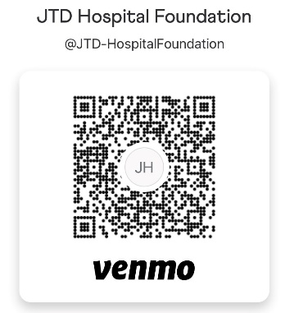
Name on Credit Card: _______________________________ Venmo: @JTD-HospitalFoundation

Address: _________________________________________

Signature: _________________________________________

I hereby release and discharge the Grand Lake Health System, JTD Hospital Foundation, USA Race Timing, Event Sponsors and their representatives or agents, from any liability for injuries or illness which may be directly or indirectly result from the participation in this event. I attest that I am physically fit and have sufficiently trained for this race.
Signature: Date:

Thank You for Your Generous Support!
For more information regarding registration or questions about the SIDS Awareness 5K, please call the
JTD Hospital Foundation office at 419-394-3387, ext.3567

