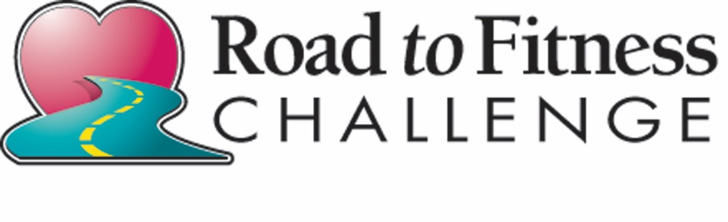
2026
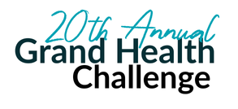
Grand Health
PART OF THE:

Fitness Challenge Based on Participation Points from the Road to Fitness Events.
Program runs from January to November 2026

Achieve Participation Points to WIN prizes!

To Participate in the 2026 Road to Fitness Challenge, please fill out the form below:
Must be at least 13 years old to participate. Parental consent required for ALL individuals under 18 years of age.
This form must be completed to be eligible for apparel and prizes.

First & Last Name: _________________________________ Sex: _M / F_ Age: _______
Address: ________________________________________________________________
City: _____________________________________________ State: ______ Zip: _______
Email: ___________________________________________ Phone: _________________
T-Shirt Size: ____________________ Men / Women (please circle one)

Mail completed form to: OR Email you information to: nthis@jtdmh.org
Grand Lake Health System
Attn: Community Outreach
200 St. Clair St.
St. Marys, OH 45885
Thanks for being a part of the Road to Fitness 2026!
For more information, please call Nicole This at 419-394-6132 or email nthis@jtdmh.org

